CrossDataHosts
Advising on real estate investment for temporal rentals

Analysts:

Kseniia Lukhlina
Lara Caçador
Angélica Roa

Problem Statement:
Our super rich client is a real estate investor interested in temporary housing rentals, who would like to know what are the best possible locations, according to price, rating and visits.

Our client has asked us to analyse an Airbnb Data Set, to give him advice on the most profitable location to invest.

Hypothesis

- (Kseniia) Identify the most frequently occurring country in the dataset and analyse the data grouped by city.
For each city, identify the correlation between price, rating and number of responses
If we find valuable correlation between the given parameters, we can determine the most attractive places for new hosts

- (Lara) Property types with high ratings but low listing volume (under-supplied niches like Guesthouse or Dome) represent stronger marketing/partnership opportunities than saturated mainstream types like Apartment — and some individual listings worldwide are already proven high-quality but still underpriced and low-visibility, suggesting the market hasn't caught up to them yet.

- (Angélica)
Questions:
- Where in the US are the most profitable locations for temporal rentals?
- How to find and visualize the most profitable locations for investment by analysing price and location?

Slides (Kseniia) - slides are discussable
slide 1. I will describe statistical results for listings in all cities of US (+ table of full statistics for price, rating and answers). I will talk about observations based on cities in US and correlations between price, rating and answers (+ table with cities, avg_prices, avg_ratings, avg_answers)
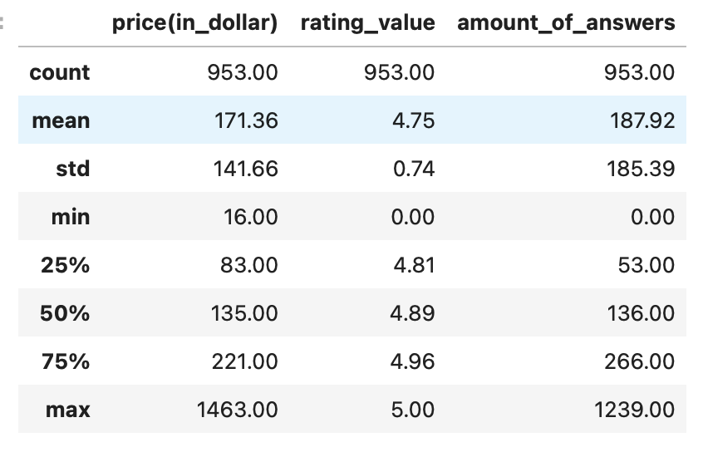

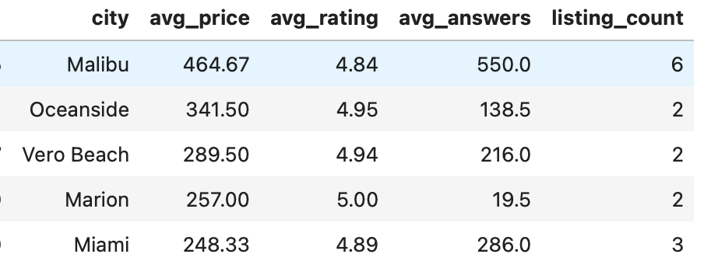
slide 2. I will think about correlations + matrix
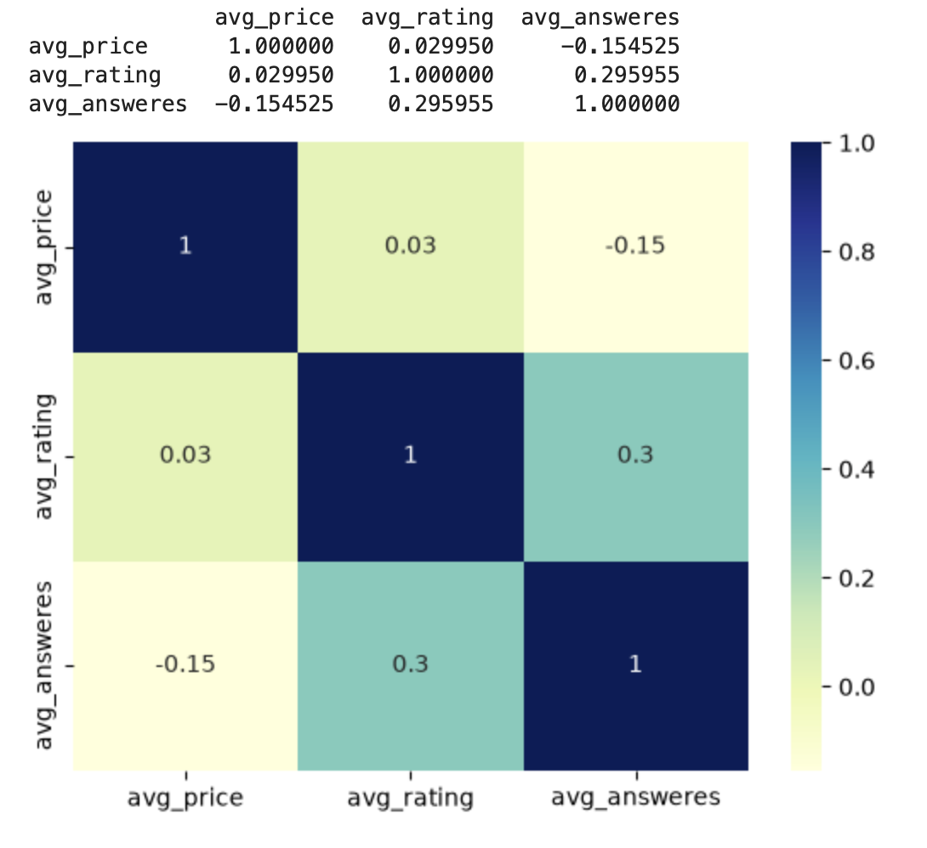

slide 3. briefly speech about cities and prices + the last column plot
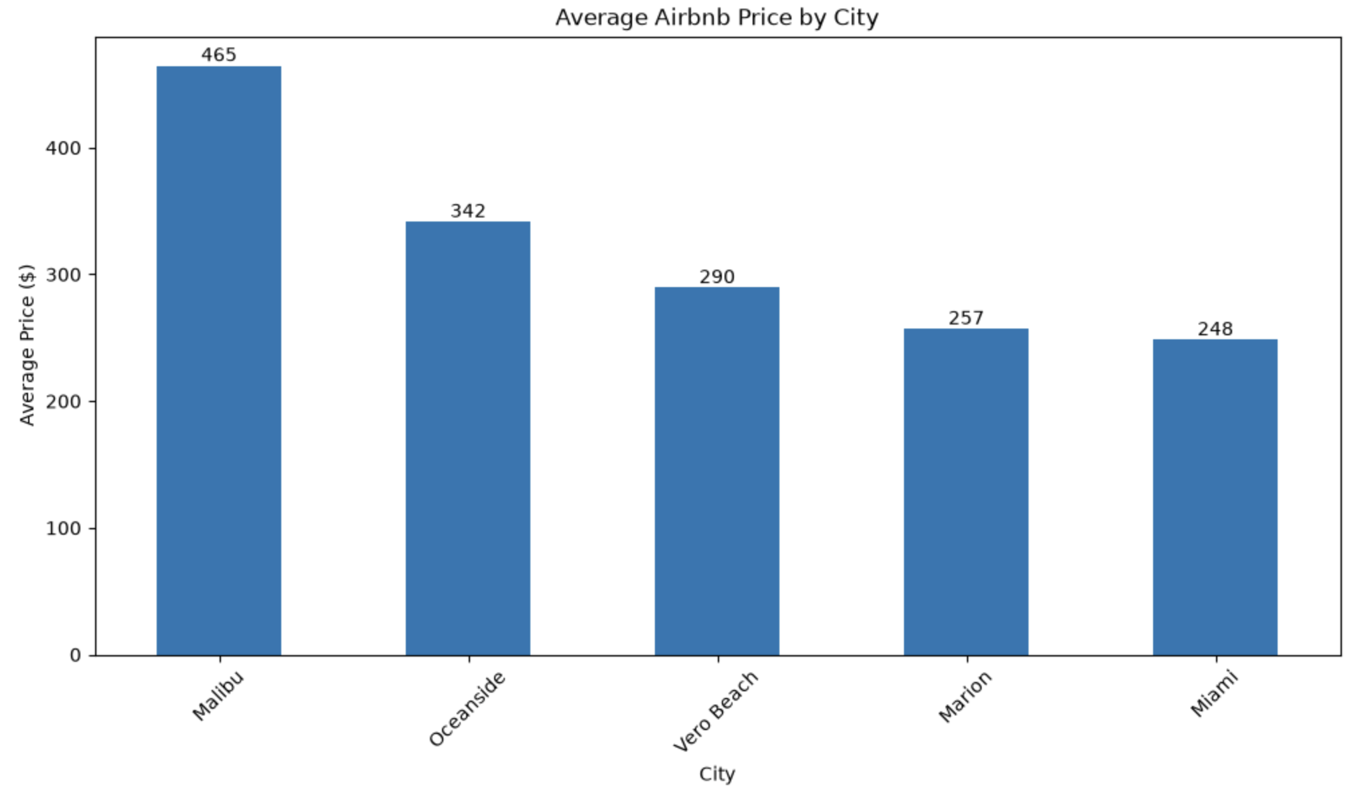

Slides Lara
Slide 1. Property types worth investing in. Guesthouse, Dome and Guest suite lead in rating (~4.9) and popularity (300-400+ reviews) but have very few listings (10-22) — under-supplied niches with proven demand. Apartment/Home have the highest volume (105-107) but lower rating — saturated. Bar chart included.

Slide 2. Where to bet, right now. Building on Kseniia's city table — applying a reliability filter (min. 5 listings per city) narrows it down to Malibu and Miami Beach. Deep dive on Malibu: 110,621$ avg. annual revenue(source: AirROI- report from rental industry, also cant forget to quote this “Malibu hosts earn about 110,621$ per year on average <-> Metrics reflect trailing twelve-month aggregates from active listings; data from August 2025 until July 2026”). Why: Malibu has only ~130 hotel rooms for 21 miles of coastline, per an official California Coastal Commission report-> real, government-confirmed demand.(cant forget to add the links of the sources on the ppt, the CCC report being the strongest one since it’s from the government itself)
Slide 3. What's next. 21 "hidden gem" listings worldwide -> perfect 5.0 rating, almost no reviews, priced way below average (e.g. a room in Bali for 29$). Price barely correlates with quality/demand in this market, which is exactly why these gems exist. Framed as candidates for a future Phase 2 international expansion.

SLICES ANGÉLICA
Slice 1: Data Cleaning
Data Frame Clean After:
- Evaluating Null Values
- Identifying and dropping duplicates
- Dropping unnecessary columns for this study
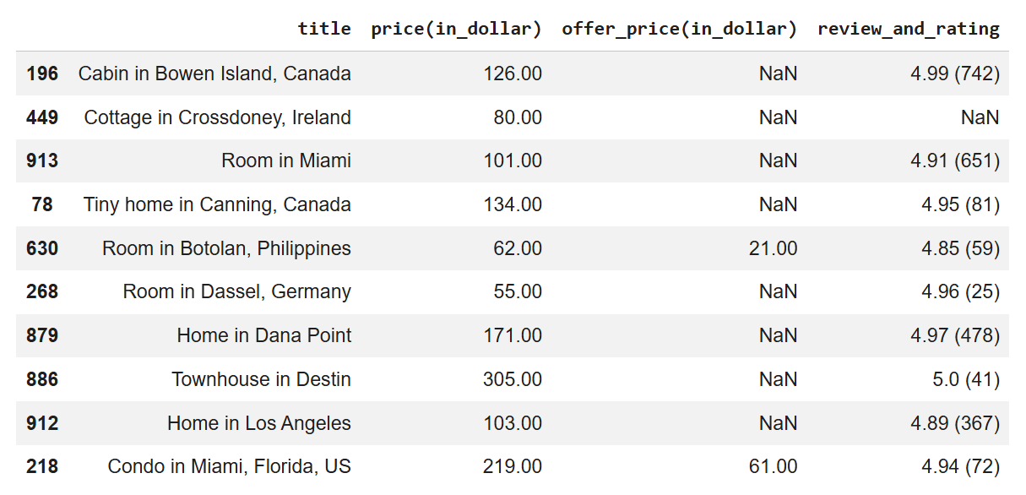
NEXT STEP: This allows us to identify that the Column 'title' actually contains information about the location but it needs to be extracted, as well as separate the information about rating and reviews.

Slice 2: Extracting Information
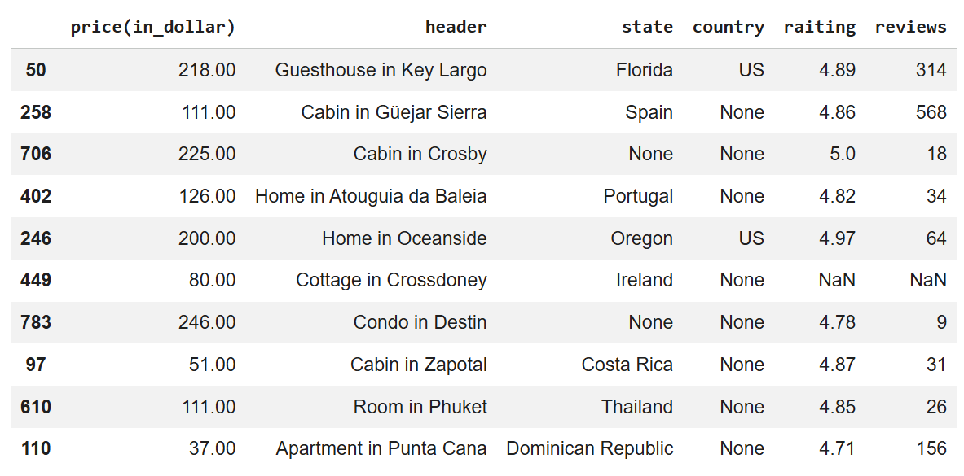
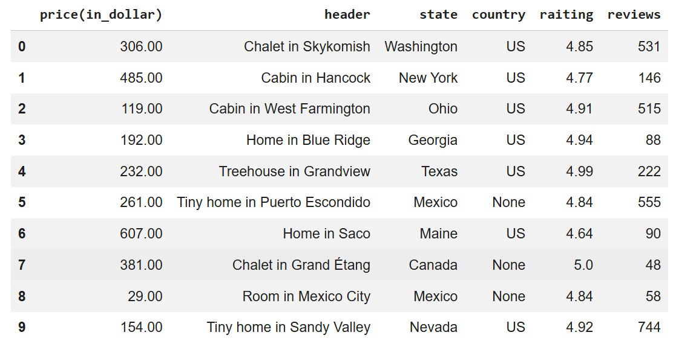
NEXT STEP: This allows us to observe that in the new column “header” there is information about the location (or city?) but there are many “None” values in country that need to be filled with the information about in ‘state’, this could work particularly for US so it’s time to filter to US

Slice 3: Finding Location
I split using “in” as a separation to get the location in a separated column.
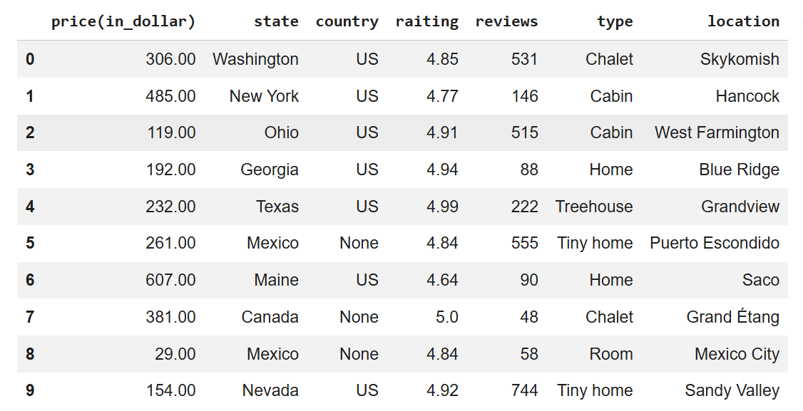
- After checking some of these locations in google effectively, I had the idea to find their coordinates “latitude” and “longitude”.
- However there are 733 None Values in “Country”, we need the complete information of (location, state, country) in the US.
NEXT STEP: Create a dictionary with the states of US, check the info in the column “State” and if the state matches the information, fill the None = US

Slice 4: Location Clean filtered in US!
108 LOCATIONS FOUND,with specific name of location and state
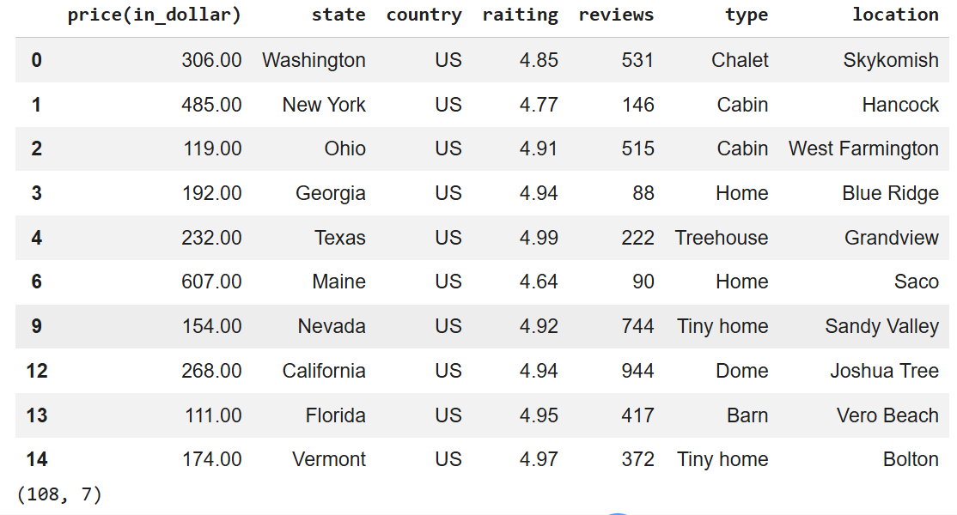
NEXT STEP: Easy Connecting with Google Maps!
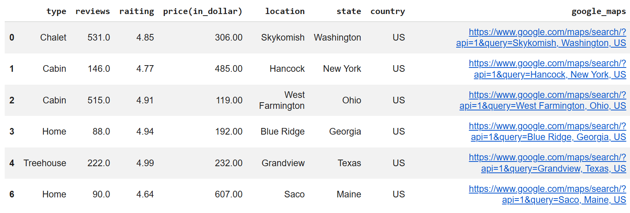
However! The google link does not allow to get the coordinates
NEXT STEP: Go simple! Try GEOPY.GEOCODERS for Geolocalization, to obtain the coordinates “latitude” and “longitude” to add it to the study

